Touch script.sh

Chmod +x script.sh

Nano script.sh

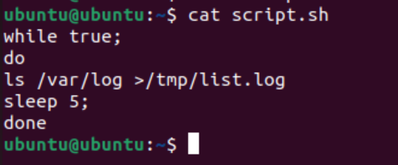

Copying script:

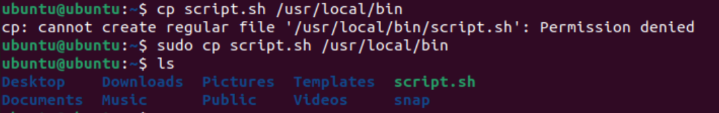

Creating srvs:



Enabling service:

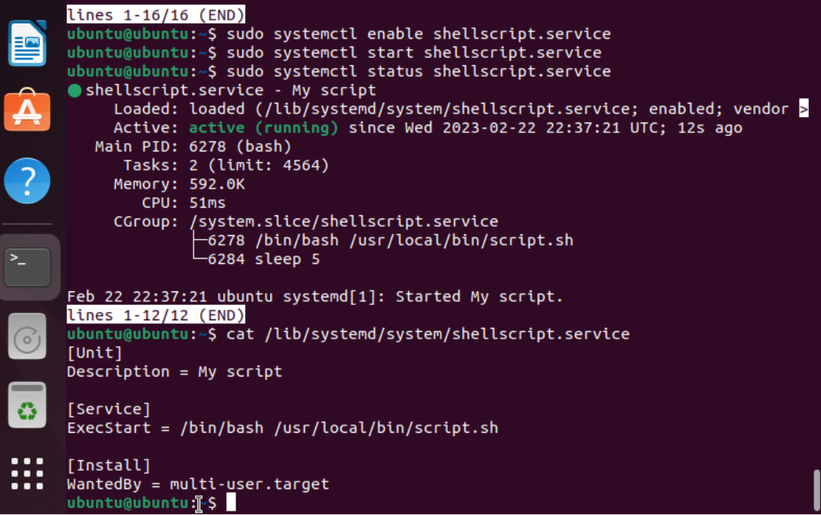

Copy and compress:

Select 1..

\*/5 \* \* \* \* zip -r /tmp/list.log.1.zip /tmp/list.log